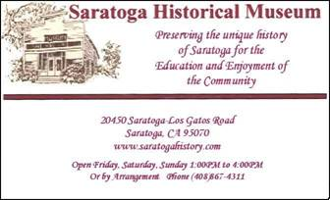

**Louise and George Cooper Historical Essay Contest**

For all 4th and 5th graders going to school in Saratoga:

public, private and home-school

**2020 Topic – Remembering Saratoga’s Railroad Connections**

**Background:**

Did you know that at one time, Saratoga had an Interurban Railroad station downtown where Blaney Plaza is today?

The following are some ideas you might consider for your essay. You don’t have to answer all these questions. Essay judges are not looking just for a factual report, but memories, opinions, and “historical fiction” stories.

* How do you think the railroad influenced our town?
* Who worked on the train? Make up a story to describe a workday on the train.
* Have you been on a passenger train? Take a ride:

Cal Train Santa Clara or Sunnyvale stations

Roaring Camp

Niles Canyon

and make up a story or describe your ride.

* Visit Saratoga Museum and History San Jose to find out more.
* Do you think Saratoga needs a railroad today? Explain.

**Win Cash Prizes! 3 Winners per grade level:**

**1st Place - $50 PLUS**

**2 tickets to ride Niles Canyon RR (first place only)**

**2nd Place - $30**

**3rd Place - $20**